



📊 Project Overview & Objectives

* The primary objective of this project is to perform a comprehensive analysis of the organization’s sales data to uncover actionable insights that drive strategic business decisions and enhance overall performance.
* Through systematic data analysis and visualization, the project seeks to identify meaningful trends, patterns, and relationships that strengthen decision-making across key business areas such as sales strategy, marketing, and operations.
* The initiative will conclude with the creation of an interactive sales dashboard 💻 — providing stakeholders with real-time, visual access to critical performance metrics, thereby empowering data-driven decisions that support sustainable business growth.

🎯 Project Goals

1. **Track Sales Trends Over Time**

Analyse historical sales data to identify patterns, seasonal variations, and growth trends.

This helps in understanding demand fluctuations, forecasting future sales, and aligning marketing and inventory strategies with customer behaviour and market dynamics.

1. **Highlight Top-Performing Products, Categories, and Channels**

Identify the best-performing products, categories, and sales channels that contribute most to revenue and profitability.

These insights enable the business to focus resources on high-impact areas, replicate successful strategies, and optimize the overall product and channel mix.

1. **Evaluate the Impact of Discounts and Returns on Profitability**

Assess how discount strategies and product returns influence total sales and net profitability.

This evaluation guides the development of optimal discount structures, minimizes revenue loss, and improves profit margins.

1. **Develop an Interactive Sales Dashboard 💻**

Design and implement an interactive dashboard to visualize key performance indicators (KPIs) such as sales growth, revenue distribution, return rates, and product performance.

The dashboard will act as a centralized, user-friendly platform for management to monitor performance, identify trends, and make data-backed decisions efficiently.

1. **Identify Underperforming Areas and Recommend Improvements**

Detect low-performing products, regions, or customer segments through detailed analysis.

By identifying underlying causes—such as pricing issues, limited marketing reach, or operational inefficiencies—the project will propose targeted strategies to enhance overall performance.

1. **Deliver Actionable Insights and Recommendations 📊**

Provide strategic, data-driven recommendations to improve sales outcomes, optimize operations, and boost profitability.

These insights form the foundation for continuous improvement, supporting long-term growth and competitive advantage.

**📂 Dataset Overview**

* The Superstore Sales Dataset serves as the foundation for this analysis, offering a comprehensive view of the company’s sales operations across various regions, product categories, and customer segments.
* The dataset contains 9,994 records, each representing an individual transaction, and includes detailed attributes describing order information, customer details, shipment modes, product hierarchies, and financial metrics.
* This dataset is instrumental in analysing business performance, uncovering customer purchasing trends, and assessing profitability across multiple dimensions. Its structured design enables in-depth analytical exploration and supports data-driven decision-making for strategic business growth. 💡

🗂️ Key Columns and Their Significance

• **Order ID:** A unique identifier assigned to each sales transaction, ensuring traceability and enabling detailed order-level analysis.

• **Order Date:** Indicates when the order was placed; used to analyse temporal sales trends and identify seasonal variations.

• **Ship Date:** Specifies when the product was shipped, helping evaluate delivery timelines and logistics performance.

• **Ship Mode:** Describes the mode of shipment (e.g., Standard Class, Second Class, First Class, Same Day) — essential for assessing logistics efficiency and customer preferences. 🚚

• **Customer ID and Segment:** Identify unique customers and categorize them into Consumer, Corporate, or Home Office segments. Enables customer segmentation analysis and performance comparison.

• **Product ID, Category, and Sub-Category:** Define product hierarchies, allowing for comparative analysis across different product types and categories.

• **Sales, Quantity, Discount, and Profit:** Represent the core financial and operational metrics, forming the foundation for evaluating sales performance and profitability. 💰

• **Region, State, and City:** Provide geographic segmentation, facilitating analysis of regional sales patterns and market performance.

**🧹Data Cleaning and Preparation Process**

Before performing any analysis, it was crucial to ensure the dataset was **accurate, consistent, and analysis-ready**. Data cleaning played a key role in enhancing **data reliability** and minimizing errors that could distort analytical insights.

The following steps outline the systematic process undertaken to prepare the dataset for analysis:

**1. Removal of Duplicates and Blanks:**

Duplicate entries were identified using unique identifiers such as Order ID and Customer ID and subsequently removed to maintain data integrity.

Blank or incomplete records missing essential values (e.g., Sales or Profit) were reviewed carefully — if recovery was not possible, such records were excluded to ensure accuracy and validity.

**2. Handling Missing Values:**

The dataset was examined for missing or null values across all fields.

For non-critical variables, missing data were imputed using appropriate methods such as mean, median, or mode substitution, depending on data type and context.

**3. Data Formatting and Standardization:**

To ensure uniformity across all attributes, standard formatting rules were applied:

* 📅 **Date Fields:** Reformatted to a consistent structure (DD-MM-YYYY) to support time-series analysis.
* 🔢 **Numerical Fields:** Converted to standardized numeric formats, verified for valid ranges to ensure accurate calculations.
* **Text Fields:** Cleaned to remove spaces, fix capitalization, and correct typographical inconsistencies — ensuring consistency across categories, regions, and segments.

**4. Outlier Detection and Treatment:**

Outlier analysis identified extreme or unusual values that could skew insights.

For example, unusually high discounts or negative profit margins were flagged for review.

Techniques such as the Interquartile Range (IQR) method and box plot visualization were used to detect anomalies, which were then adjusted, capped, or excluded to maintain realistic representation of business data.

**5. Data Validation and Quality Assurance 🧾:**

After cleaning, a final validation phase was conducted to ensure data completeness and logical consistency.

This involved verifying relationships (e.g., Profit = Sales – Cost), checking categorical values against valid lists (e.g., shipping modes, product types), and confirming that metrics fell within logical ranges.

This validation guaranteed that the dataset was error-free, internally consistent, and ready for analysis and visualization.

**✅Outcome of the Data Cleaning Process**

Following the completion of all data cleaning steps, the dataset was transformed into a high-quality, analysis-ready format.

It is now well-structured, free from duplicates and inconsistencies, and standardized to ensure accurate visualization and reliable insight generation.

The refined dataset serves as a robust foundation for subsequent analytical stages — including performance measurement, trend analysis, and interactive dashboard development — enabling confident, data-driven decision-making. 📊

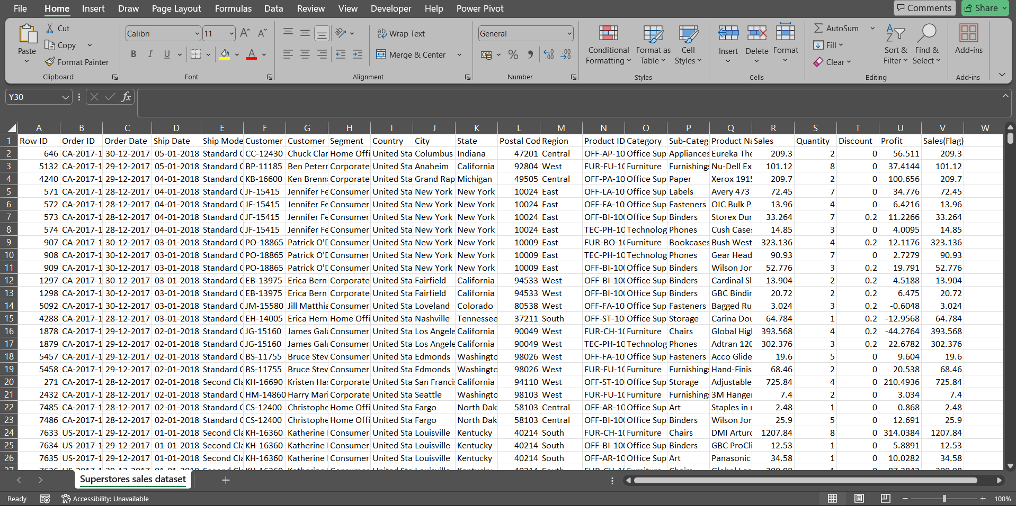 RAW DATA

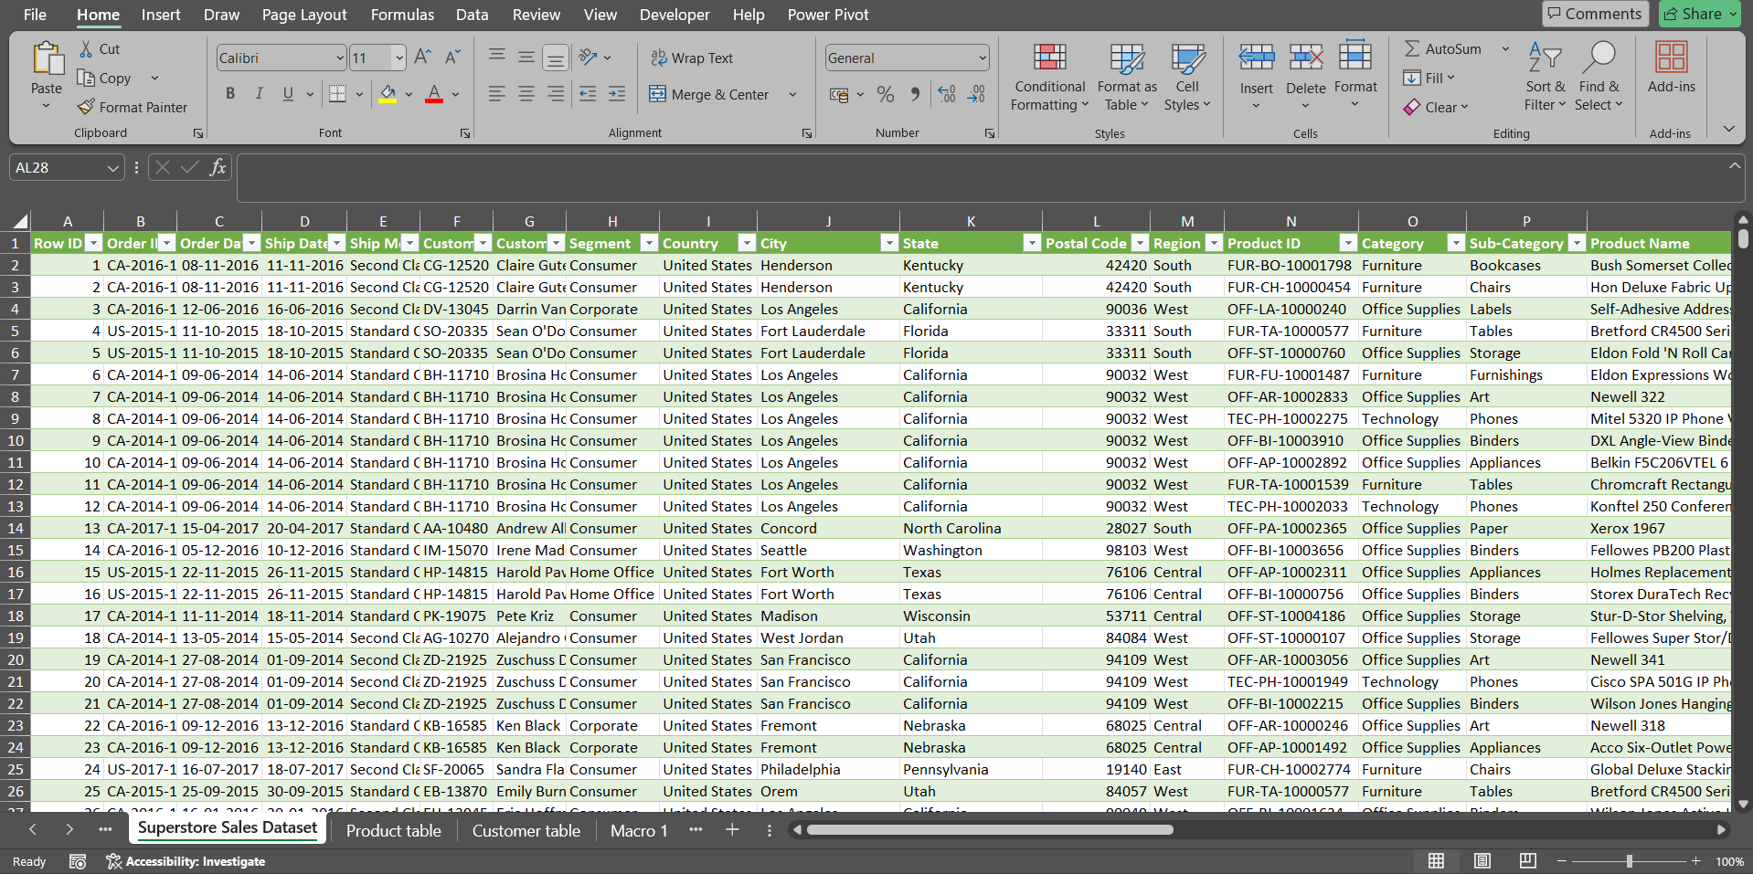 CLEANED DATA

**📈 Key Metrics**

The analysis of the **Superstore Sales Dataset** focuses on several **key performance indicators (KPIs)** that are essential for understanding **business performance**, **sales trends**, and **profitability drivers**.

**1. Total Orders**

Formula: =COUNT(Order_ID)

This metric calculates the total number of orders or unique transactions recorded in the dataset.

It provides insight into overall sales volume, helping assess customer demand levels and monitor purchasing frequency.

Tracking total orders enables the organization to evaluate marketing effectiveness and identify seasonal peaks in demand.

**2. Total Sales 💰**

Formula: =SUM(Sales)

Represents the aggregate revenue generated from all transactions before any discounts or adjustments.

It serves as a primary measure of the company’s gross sales performance and overall market reach.

**3. Total Adjusted Sales**

Formula: =SUM(AdjustedSales)

Reflects the net revenue earned after accounting for discounts, returns, or adjustments.

Unlike total sales, this metric offers a realistic measure of actual earnings, providing a clearer view of business profitability.

**4. Average Sales per Order**

Formula: =AVERAGE(AdjustedSales)

Indicates the average transaction value (ATV) — the typical revenue generated per order.

This metric helps analyse customer purchasing behavior and reveals opportunities for cross-selling, bundling, or targeted promotions. 📊

**5. Total Discount Value**

Formula: =SUM(DiscountValue)  
Quantifies the aggregate value of discounts applied across alltransactions.  
It helps evaluate the impact of discounting strategies on total revenue and profitability.

**🛒 Sales by Channel and Product Type**

In addition to overall KPIs, performance was analysed across sales channels (e.g., Online, Retail, Corporate) and product categories to identify high-performing segments and areas for improvement.

Conditional Excel functions such as COUNTIF, SUMIF, and AVERAGEIF were used to derive insightful metrics for each dimension, enabling a deeper understanding of channel performance and product mix effectiveness.

**1. COUNTIF – Total Orders by Channel or Product Type**

Formula: =COUNTIF(Channel/Product Range, Criteria)

The COUNTIF function calculates the number of orders for each sales channel or product type.

This helps determine where customer engagement is strongest and which channels contribute most to total sales volume.

For example, a higher count in the Online channel may reflect growing e-commerce demand, whereas a lower corporate count could signal the need for targeted B2B strategies.

**2. SUMIF – Total Discounts and Adjusted Sales by Channel or Product Type 💰**

Formulas:

=SUMIF(Channel/Product Range, Criteria, Discount Range)

=SUMIF(Channel/Product Range, Criteria, Adjusted Sales Range)

These formulas summarize the total discounts and adjusted sales values by channel or category, offering insights into revenue contribution and discount distribution across business segments.

**3. AVERAGEIF – Average Discount by Channel or Product Type 📊**

Formula: =AVERAGEIF(Channel/Product Range, Criteria, Discount Range)

The AVERAGEIF function calculates the average discount rate or value for each channel or category.

This metric highlights pricing and promotional variations, helping management assess discount effectiveness and identify pricing optimization opportunities.

**💡 Summary and Insights**

The key metrics outlined above provide a comprehensive view of business performance across multiple dimensions — including sales growth, profitability, and operational efficiency.

By integrating these quantitative insights with interactive visual dashboards, the organization can track performance trends, identify growth opportunities, and make informed, data-driven decisions that strengthen overall business strategy. 📊

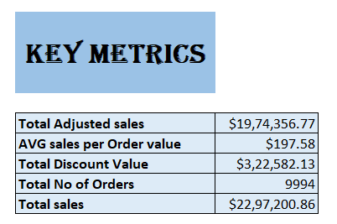

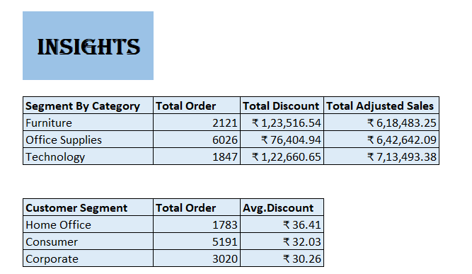

**🗄️ Data Modelling: Data Model Description**

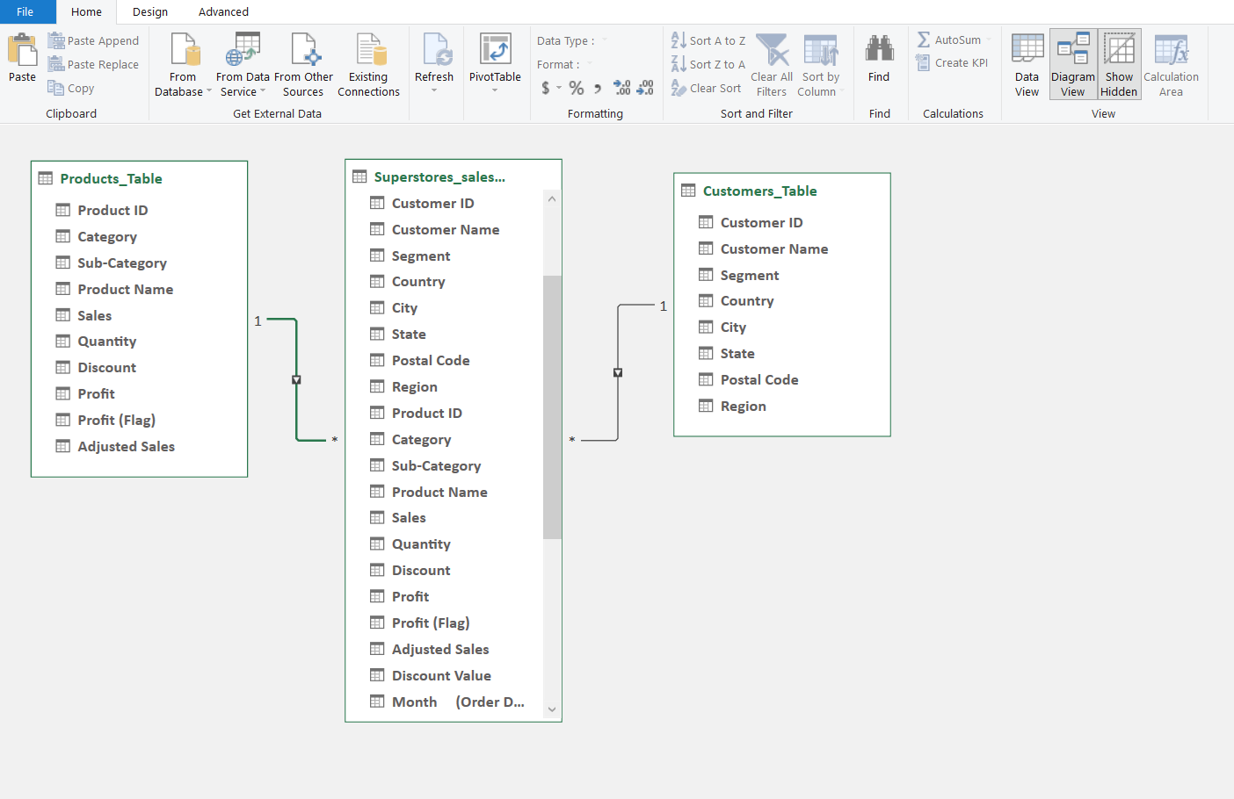

This data model is designed to analyse Superstore Sales by integrating information from three key tables: Product Table, Customer Table, and Superstore Sales Table.The relationships between these tables are established using Product ID and Customer ID as primary linking keys, ensuring accurate data integration and enabling comprehensive analysis across products, customers, and sales transactions. 💻

🗂️ Tables Overview

**1. Product Table**

Contains detailed information about each product sold.

Key Fields: Product ID (PK), Category, Sub-Category, Product Name, Sales, Quantity, Discount, Profit, Adjusted Sales.

**2. Customer Table**

Holds customer details.

Key Fields: Customer ID (PK), Customer Name, Segment, Country, State, City, Postal Code, Region.

**3. Superstore Sales Table 💻**

The fact table recording every transaction, linking Product and Customer tables via Product ID and Customer ID.

Key Fields: Customer ID (FK), Product ID (FK), Sales, Profit, Quantity, Discount, Category, Sub-Category, Region, Country.

**Relationships:**

Product → Sales: 1→Many; each product appears in multiple transactions.

Customer → Sales: 1→Many; each customer can make multiple purchases.

**🎯 Purpose of the Model**

This data model supports analysis of:

* Total sales and profit by product, category, or region.
* Customer purchase behavior across segments and locations.
* Product performance comparisons across customers, states, and time periods.
* Identification of top customers and best-selling products.

It provides a foundation for dynamic reporting and visualization in BI tools such as Power BI, Tableau, or Excel Data Model. 💻

**📊 Pivot Table Analysis**

Pivot tables were used to transform raw sales data into structured, actionable insights, summarizing performance across sales channels, product categories, and time periods.

**1. Mapping the Terrain: Aggregated Sales Overview**

* Aggregated sales data by:
* Sales Channel: Online, Corporate, Retail
* Product Category/Sub-Category: Item-level performance
* Order & Ship Dates: Temporal trends and seasonality

This created a bird’s-eye view of business performance for deeper analysis.

**2. Spotting the Gold: Identifying Revenue Hotspots 💰**

Pivot table summaries highlighted high-performing areas using key metrics:

* Total Sales (=SUM(Sales))
* Average Sales per Order (=AVERAGE(Adjusted Sales))
* Total Discount Value (=SUM(Discount))

These “golden zones” guided marketing, inventory, and pricing strategies.

**3. Fast-Tracking Insights: Rapid Performance Evaluation**

Interactive pivot elements like slicers and filters enabled real-time comparison of:

* Top-performing products, categories, and regions
* Underperforming areas needing strategic focus
* Sales, profit, and discount metrics side-by-side for quick evaluation 💻

**Summary of Pivot Table Insights**

• The pivot table analysis successfully transformed a large and complex dataset into a structured, interactive analytical model.

**Key findings include:**

• Clear visualization of sales distribution by product, channel, and time period.

• Identification of high-performing categories and channels driving revenue growth.

• Recognition of discount patterns and their influence on profitability.

• Enhanced ability to quickly analyze performance trends through dynamic filtering and visualization.

• Overall, pivot tables served as an indispensable tool for data aggregation, pattern detection, and decision support.

They provided both a macro-level overview and micro-level insights, allowing the business to make informed, strategic choices grounded in data-driven evidence.

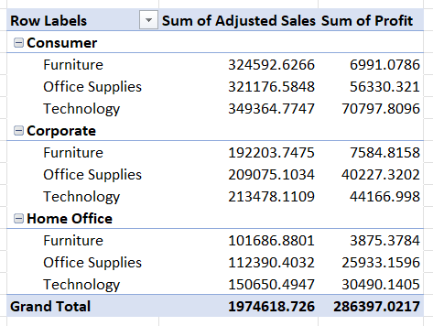

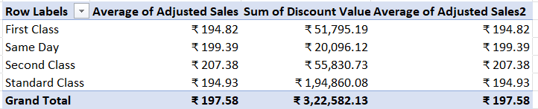

WHAT-IF ANALYSIS

* **🎯Objective**  
  To determine the required quantity of Technology items needed to achieve a total sales target of ₹750,000.
* **📊Initial Data**💲 Price per Unit: ₹102  
  📦 Initial Quantity: 6,939 units  
  💰 Initial Sales: ₹7,07,778
* **⚙️ Method Used**  
  Used Excel’s Goal Seek feature with the following parameters:
* Set Cell: D11 (Technology Sales)
* To Value: ₹750,000
* By Changing Cell: D8 (Quantity)
* **✅ Result**

📦 Updated Quantity: 25,862.07 units  
💰 Updated Sales: ₹750,000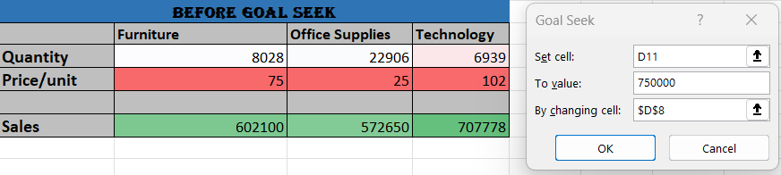

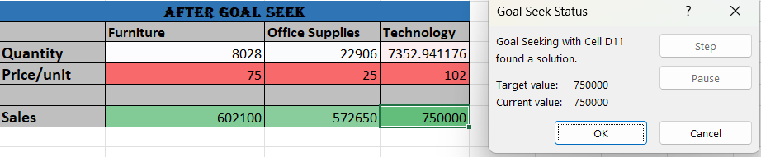

📊 Scenario Summary

📈 **Overview:** This report evaluates the impact of various sales scenarios on total revenue across a range of office and printing products.

* 💹 Sales +10%: Generated the highest revenue, showing an increase of ₹195,529.76 compared to the baseline.
* 📉 Sales -10%: Caused a significant revenue decline of ₹205,229.76 from the baseline scenario.
* 🏷️ Discount -5%: Led to a revenue reduction of ₹104,765.14, highlighting that even a small discount adjustment can noticeably affect profitability.

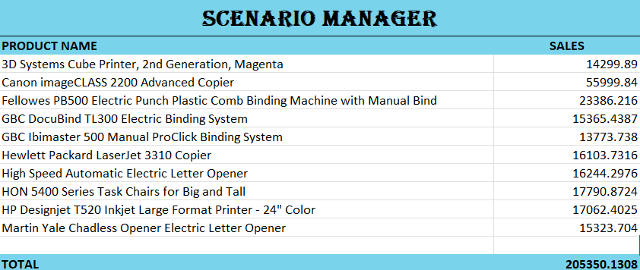

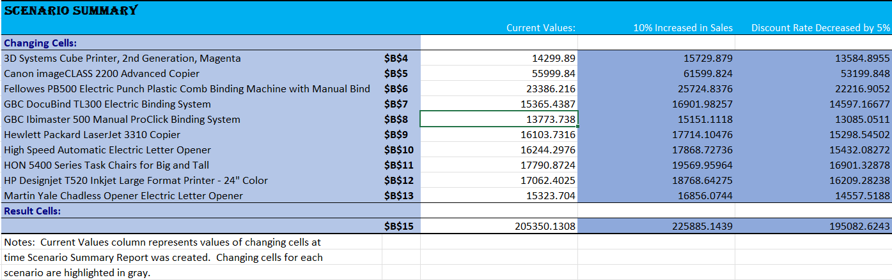

Macros and Automation

**⚙️ Macro Recording**

🖥️ **Process**: Automated repetitive tasks such as data formatting, complex calculations, and report generation, streamlining routine Excel operations.

✅ **Benefits:**  
⏱️ Time-Saving – Reduced manual effort and increased productivity.  
⚡ Efficiency – Simplified workflows and accelerated data processing.  
📋 Consistency – Ensured uniform formatting and reliable results.  
🧩 Error Reduction – Minimized human errors in data handling and analysis.

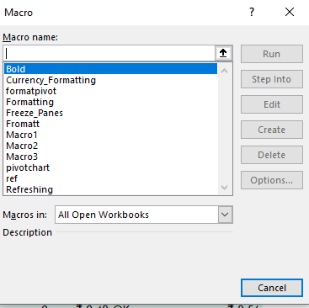

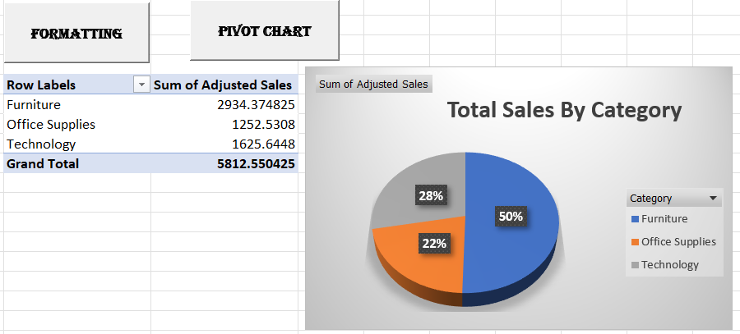

💡 Key Insights

🏆 **Top Categories & Segments**  
• 💻 Best-Selling: Technology & Office Supplies  
• 🏢 Top Segment: Corporate customers (≈50% of revenue)  
  
📆 **Sales Trends**• 📊 Steady growth across the year  
• 🎉 Peak performance in Q4 due to festive demand  
  
**🚚 Shipping & Products**  
• 📦 Most Used Shipping: Standard Class  
• 🖨️ Top Products: Printers & Office Equipment  
• 🧩 Underperformers: Small Accessories → consider bundling  
  
🌍 **Regional & Weekly Performance**  
• 🗺️ Leading States: California, New York, Texas  
• 📅 Sales Peak: Weekends → try midweek promotions

✅ Recommendations

🏷️ **Optimize Discounts**: Use data insights to minimize unnecessary discounts and protect margins.  
📉 **Boost Weak Categories**: Implement targeted promotions for underperforming areas like Furniture.  
🚀 **Leverage Top Performers**: Focus on Corporate clients & Technology products to maximize returns.  
📆 **Plan for Seasonality**: Align inventory & marketing strategies for Q4 festive demand.  
🛒 **Manage Slow-Moving Products**: Reprice, bundle, or phase out low-selling items.  
🤝 **Enhance Customer Retention**: Launch loyalty programs, referral offers, and personalized promotions.  
🚚 **Improve Delivery Performance**: Offer faster shipping options and optimize logistics.

📌 Conclusion

The Superstore Dashboard insights provide actionable strategies to:

* Implement smarter discounting to protect margins 💰
* Focus on top-selling products to maximize revenue
* Streamline delivery processes for improved efficiency 🚚
* Nurture loyal customers through targeted engagement
* Leverage seasonal and regional trends to drive growth

Together, these insights enable data-driven decisions that support sustainable business growth and enhanced profitability.